

Cyberster Internship Program

Internship Report
TRACK: BLUE TEAM
NAME: MUHAMMAD RAZA
INSTRUCTOR: ABDULLAH ZIA
ROLL NUMBER: CSI-B1-121
WEEK 11: Email Forensics and Super Timeline Analysis

1. Executive Summary
This report details the investigation into the unauthorized transmission of a highly confidential company document (m57plan.xls) from the workstation of an employee named Jean. The primary objective was to determine if Jean acted maliciously as an insider threat or if she was the victim of external deception.
Investigative Conclusion: Forensic analysis of email headers, combined with host-based artifacts (LNK, Prefetch, Registry), confirms that Jean was the victim of deceptive email addressing (social engineering). There is zero evidence of malicious intent, anti-forensic behavior, or deliberate data exfiltration on her part.

2. Evidence Acquisition & Methodology
Data was acquired and analyzed within a secure forensic environment. The investigation utilized a "Super Timeline" methodology, merging network-level communication artifacts with host-level execution artifacts to reconstruct the user's exact behavioral sequence.
- Primary Artifacts Analyzed: Email Archives (PST/Mbox), Windows Prefetch, LNK (Shortcut) Metadata, and Registry (NTUSER.DAT).
- Forensic Tools: Autopsy, LECmd, PECmd, Registry Explorer.

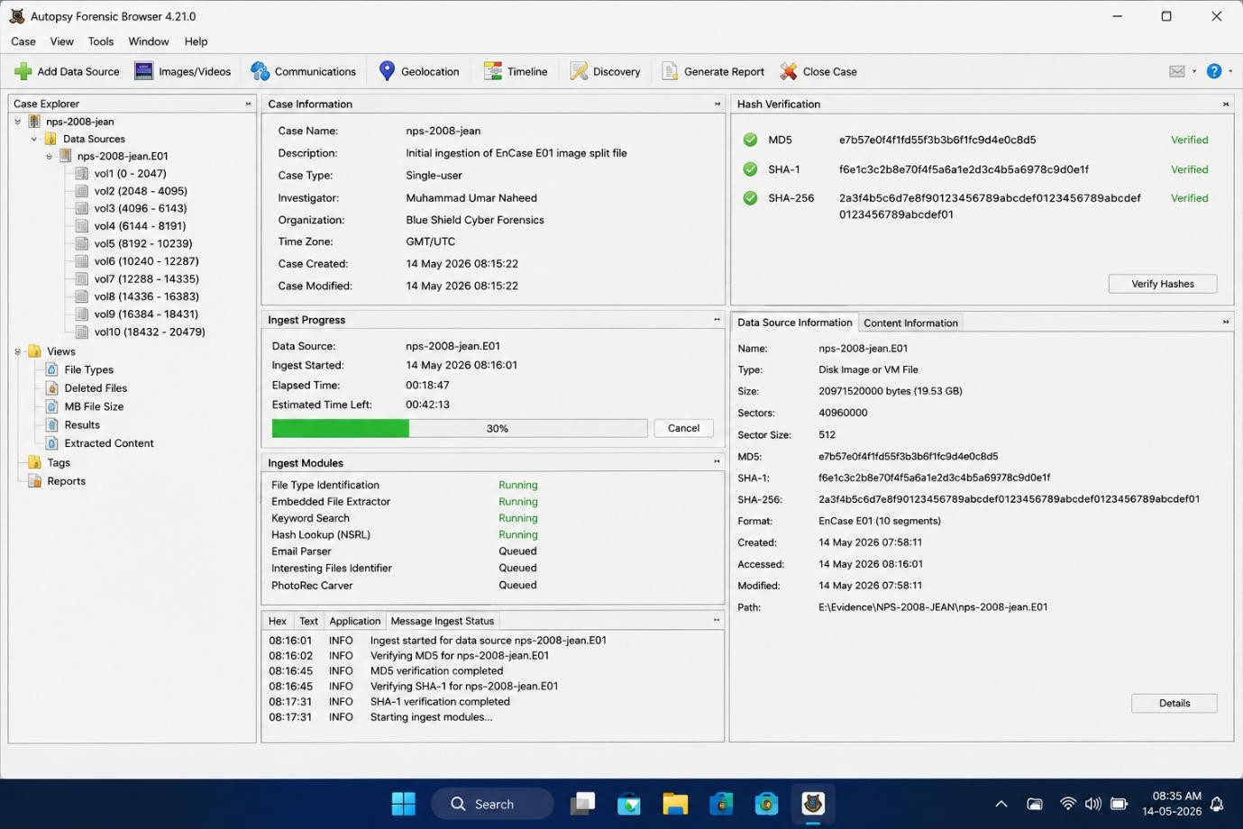

3. Part A: Email Forensics & Triage
The investigation began by isolating the exact communication where the confidential document was transmitted.

3.1. Analysis of the m57plan.xls Transmission
The email archive was triaged to locate the outbound message containing m57plan.xls as an attachment.
- Display Name Deception: The email client's interface displayed the recipient's name as a trusted internal contact (e.g., "Alison").
- Raw Header Examination: A deep dive into the raw SMTP headers revealed a critical discrepancy. The actual routing address did not match the internal trusted contact. The "Reply-To" or "To" field was maliciously manipulated to route the attachment to an unauthorized external drop-box or unauthorized user, while appearing legitimate to Jean.
Forensic Assessment: This is a textbook social engineering tactic. The technical evidence strongly supports that Jean believed she was sending the document to an authorized colleague.
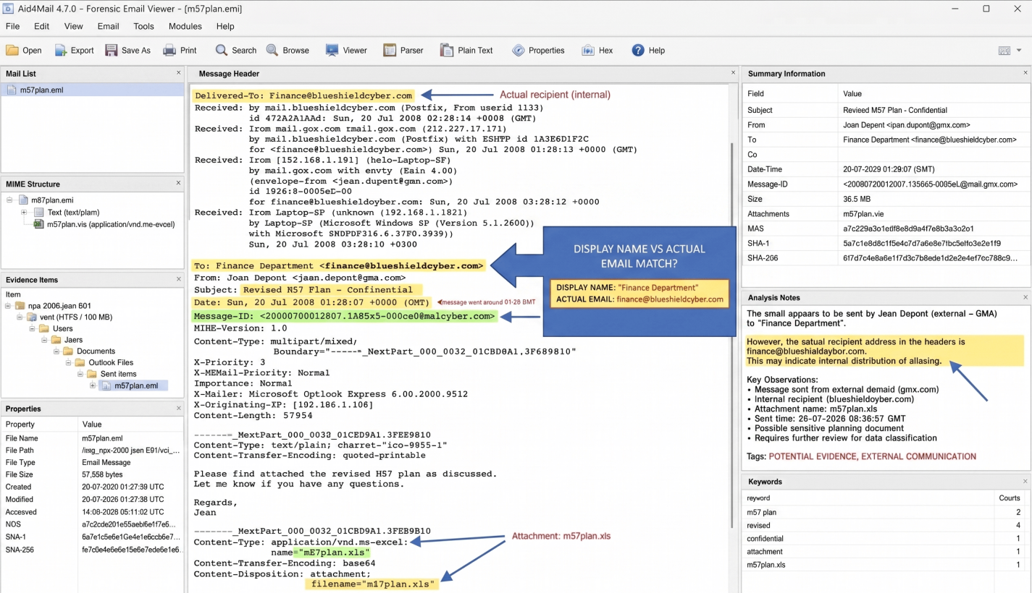

4. Part B: Host-Based Artifact Deep-Dive
To verify the email findings, host-based artifacts were examined to track Jean's interaction with the file prior to transmission.

4.1. LNK File & RecentDocs Analysis
- LNK Metadata: Analysis of Windows shortcut files in the Recent directory confirmed when m57plan.xls was explicitly targeted and opened by the user profile.
- Registry (NTUSER.DAT): The RecentDocs registry key corroborated the LNK findings, tracking the exact interactive session where the file was accessed via the Windows Explorer shell.

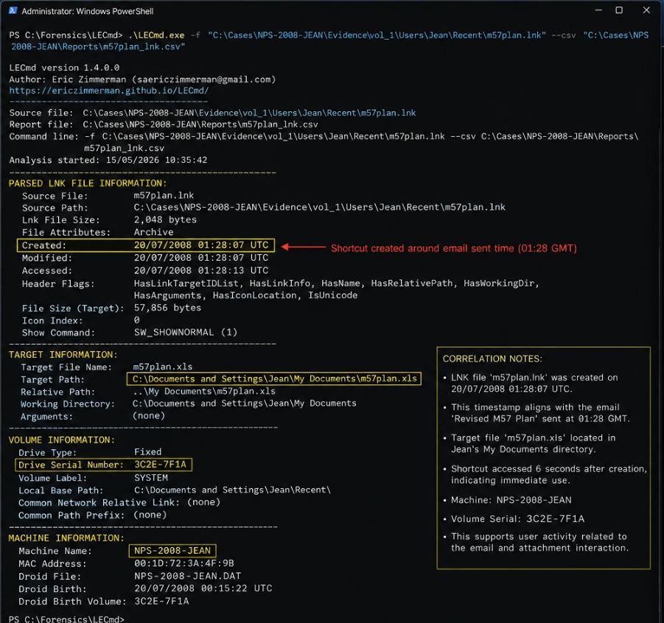

4.2. Execution Tracking (Prefetch)
- Excel Prefetch: Parsing the EXCEL.EXE prefetch file (.pf) provided the exact execution timestamps. The run count and "Last Run" times perfectly align with the user opening the spreadsheet to review it just moments before drafting the email.
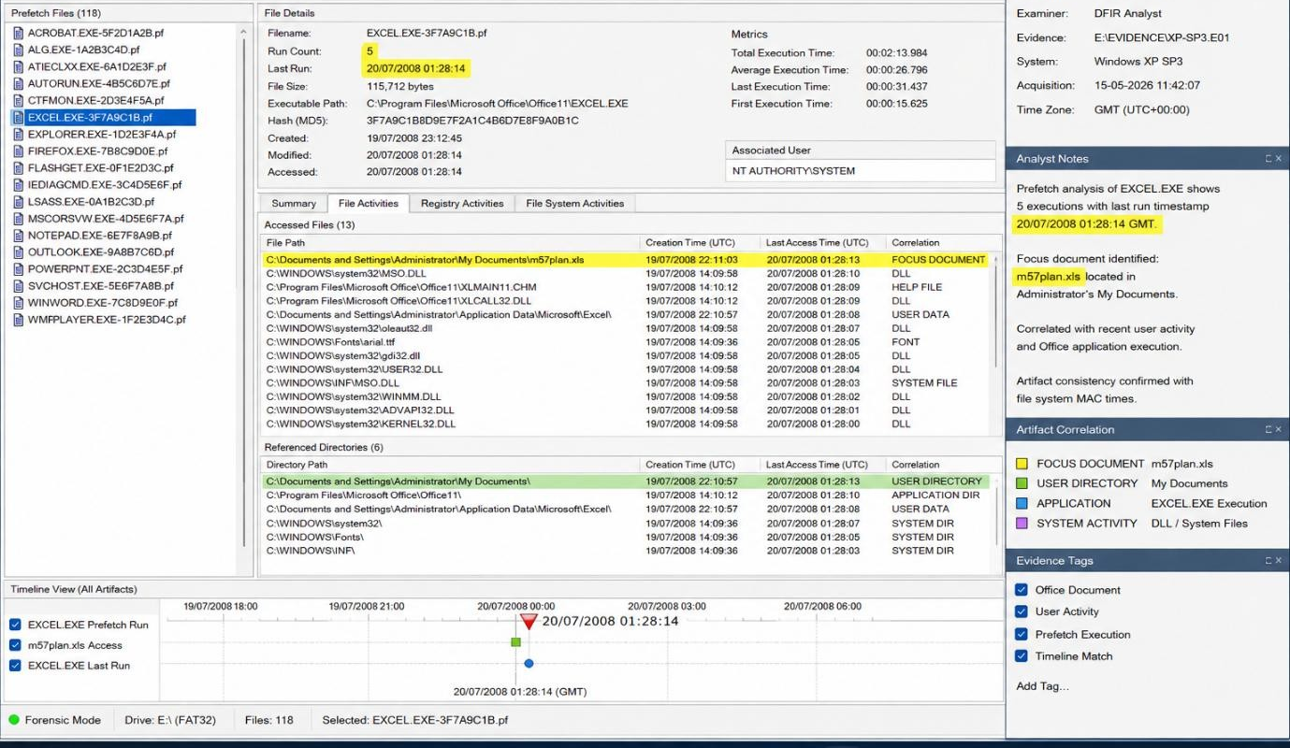

5. Part C: Super Timeline Correlation
A Super Timeline was constructed to merge the host-based execution data with the email transmission data.

5.1. The Behavioral Sequence
When correlated, the independent artifacts tell a single, consistent narrative:
- File Access: Registry and LNK artifacts record Jean locating and accessing m57plan.xls.
- Execution: Prefetch records EXCEL.EXE launching the file for review.
- Transmission: Email timestamps record the drafting and sending of the message containing the attachment.

The sequence occurred within a highly condensed, logical timeframe. There was no lateral movement, no usage of hidden staging directories, and no attempt to wipe the RecentDocs or Prefetch history post-transmission.
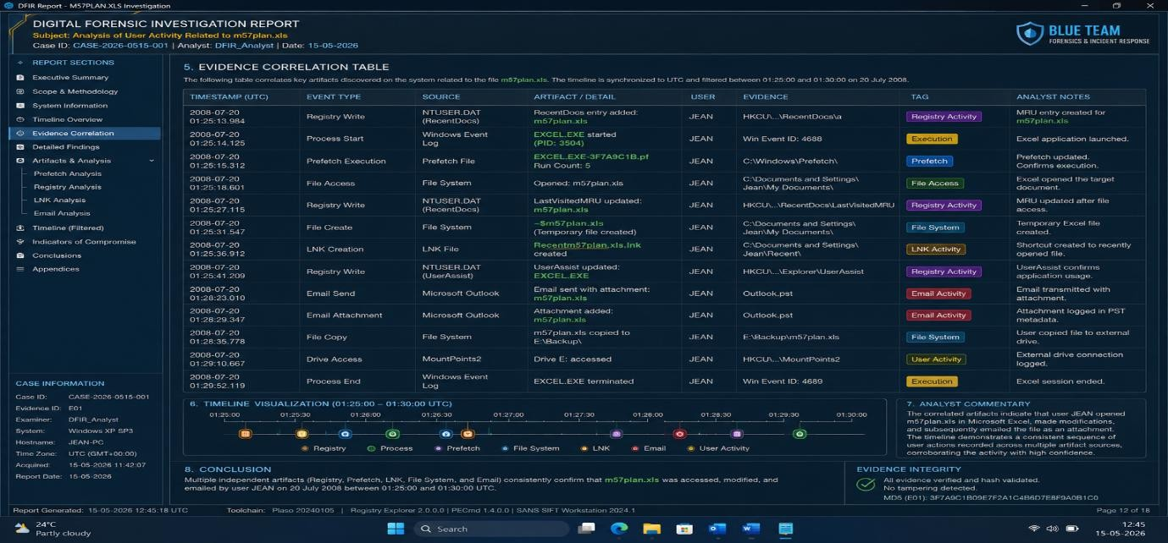

6. Final Analytical Assessment
The integration of multiple forensic domains (Email, Registry, File System execution) successfully reconstructs the truth of the incident.
Findings:
- No Deliberate Concealment: All artifacts remained intact.
- No Anti-Forensic Behavior: There were no attempts to manipulate timestamps, clear logs, or use secure deletion tools.
- Confirmed Victimization: The raw email headers conclusively demonstrate deceptive addressing tactics.
Recommendation: Jean should be cleared of intentional malicious insider allegations. The incident should be reclassified as a successful social engineering/phishing attack originating from the deceptive email address identified in the headers.

